**Data Analysis for** [Massive Bank dataset ( 1 Million+ rows) (kaggle.com)](https://www.kaggle.com/datasets/ksabishek/massive-bank-dataset-1-million-rows) **data set:**

**Q1: What was the total transaction value for all locations from 7-2022 to 8-2022**

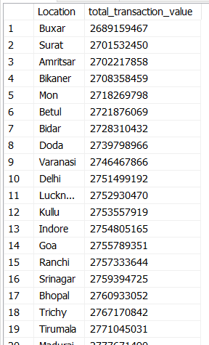

**Q2: Which location had the highest total transaction value in a specific year**



**Q3: Which domain had the most transactions on average per day for September 2022**

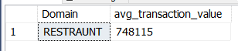

**Q4: What was the busiest day (most transactions) across all locations for 2022**

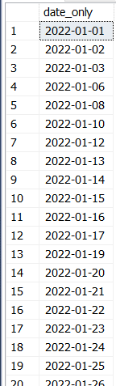

**Q5: Compare the average transaction value for each domain across all locations**

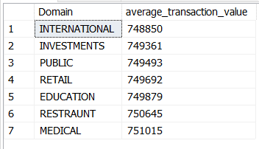

**Q6: Identify any locations with a significant increase or decrease in transaction count compared to the previous month**

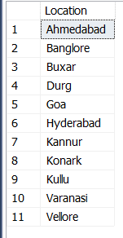

**Q7: Are there any correlations between the domain type and the location of transactions**

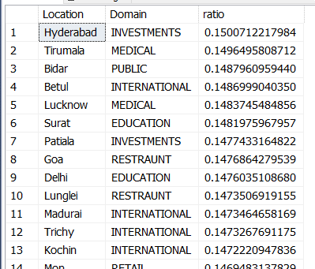

where ratio = (location mentioned with this domain)/total number location mentioned

**Q8: Segment the transactions based on value (e.g., low, medium, high) and analyze their distribution across locations and domains**

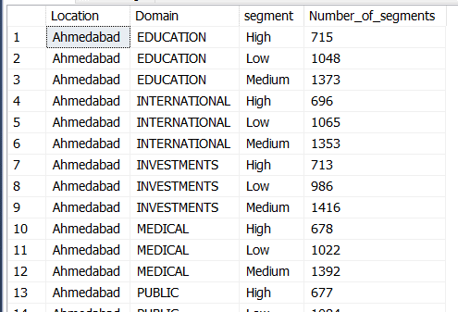

**Q9: identify seasonal trends in transaction value**



